Filterbank Manager v1.0

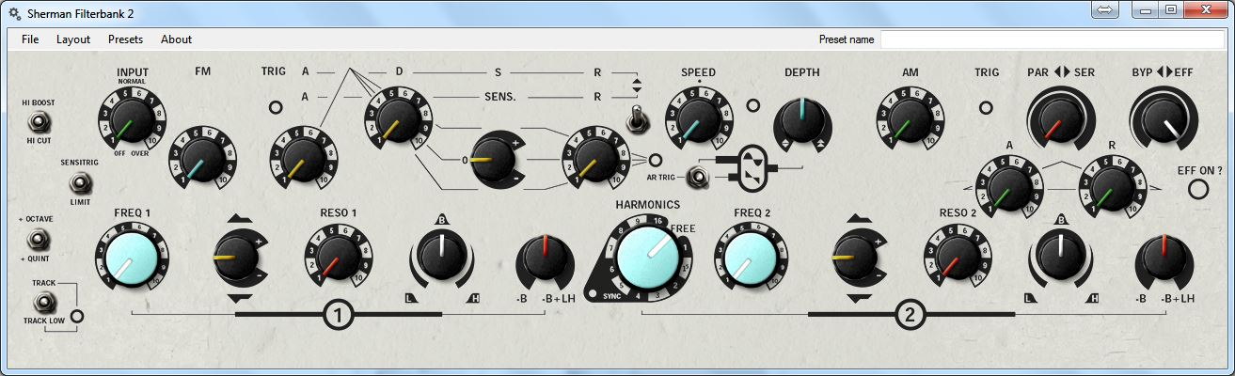

# About

I was bored with having to manually write down the settings on my Sherman Filterbank 2. The notes would just float around on my desk for a while, before finally going missing when I needed them the most...

This program will allow you to quickly note down your preset and save it as an imagefile to keep, for example, in your project folder. I included the presets that are featured in the Sherman Filterbank 2 manual for your convenience and as a demonstration…

# I’m happy to take suggestions about how the program might be improved.

# Instructions

It’s pretty simple really…

* Install and start the program
* Set up your virtual Filterbank and give your preset a name
* Save your settings as an sfb-file for later use or for sharing online
* Choose the layout you want
  + REALISTIC (Looks like a real Filterbank / not very printer friendly / slightly less readable)
  + SCHEMATIC (More symbolic representation / easily printable / very readable)
* Save your settings as an image and keep it in your project folder.

And there you are… You don’t have to worry anymore about not remembering the settings you used in this or that project. Keep your presets organized without hassle…

# Thanks!

Thanks to **Herman Gillis at Sherman** for creating one of the most useful pieces of musical hardware ever conceived. The background for the interface was taken from the Filterbank 2 manual. – [www.sherman.be](http://www.sherman.be/)

Thanks to the genius known as **g200kg** for creating the little program called KnobMan I used for creating the knobs on the interface. – [www.g200kg.com](http://www.g200kg.com/)

Thanks to **AZ** for making the switch I used as a base to create the switch in the Filterbank Manager GUI. – [bji.yukihotaru.com](http://bji.yukihotaru.com/)

# contact me

Let me know what you think of this program…

[www.couvertsmusic.com](http://www.couvertsmusic.com) // [robin@couvertsmusic.com](mailto:robin@couvertsmusic.com)